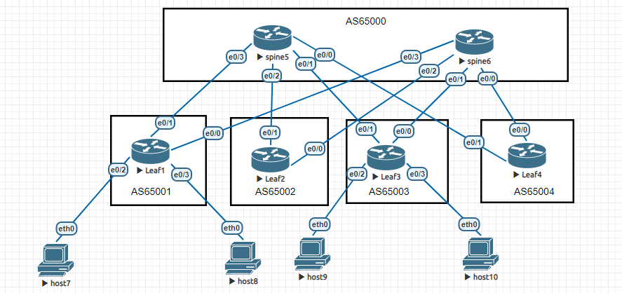

Задание №1
Для указанной топологии необходимо настроить маршрутизацию eBGP для underlay сети DC.
Задание №2*
Настройте ECMP для балансировки трафика в Underlay сети по линкам до разных spine.
Решение:
AS-номера по схеме:
Spine5 — AS 65000 / Spine6 — AS 65000
Leaf1 — AS 65001
Leaf2 — AS 65002
Leaf3 — AS 65003
Leaf4 — AS 65004

Underlay P2P адресация (/31):
Spine5 e0/3 — Leaf1 e0/1 | 10.0.0.0/31

Spine6 e0/3 — Leaf1 e0/0 | 10.0.0.2/31

Spine5 e0/2 — Leaf2 e0/1 | 10.0.0.4/31

Spine6 e0/2 — Leaf2 e0/0 | 10.0.0.6/31

Spine5 e0/1 — Leaf3 e0/1 | 10.0.0.8/31

Spine6 e0/1 — Leaf3 e0/0 | 10.0.0.10/31

Spine5 e0/0 — Leaf4 e0/1 | 10.0.0.12/31

Spine6 e0/0 — Leaf4 e0/0 | 10.0.0.14/31
Клиентские сети:
Leaf1: 192.168.1.0/24
Leaf3: 192.168.3.0/24

Конфигурации:

LEAF1 (AS 65001)
hostname Leaf1
interface e0/0
ip address 10.0.0.3 255.255.255.254
no shutdown
interface e0/1
ip address 10.0.0.1 255.255.255.254
no shutdown
interface e0/2
ip address 192.168.1.1 255.255.255.0
no shutdown
interface e0/3
ip address 192.168.1.2 255.255.255.0
no shutdown
router bgp 65001
bgp log-neighbor-changes
neighbor 10.0.0.0 remote-as 65000
neighbor 10.0.0.2 remote-as 65000
address-family ipv4
network 192.168.1.0 mask 255.255.255.0
neighbor 10.0.0.0 activate
neighbor 10.0.0.2 activate
maximum-paths eibgp 2
exit-address-family

LEAF2 (AS 65002)
hostname Leaf2
interface e0/0
ip address 10.0.0.7 255.255.255.254
no shutdown
interface e0/1
ip address 10.0.0.5 255.255.255.254
no shutdown
router bgp 65002
bgp log-neighbor-changes
neighbor 10.0.0.4 remote-as 65000
neighbor 10.0.0.6 remote-as 65000
address-family ipv4
neighbor 10.0.0.4 activate
neighbor 10.0.0.6 activate
maximum-paths eibgp 2
exit-address-family

LEAF3 (AS 65003)
hostname Leaf3
interface e0/0
ip address 10.0.0.11 255.255.255.254
no shutdown
interface e0/1
ip address 10.0.0.9 255.255.255.254
no shutdown
interface e0/2
ip address 192.168.3.1 255.255.255.0
no shutdown
interface e0/3
ip address 192.168.3.2 255.255.255.0
no shutdown
router bgp 65003
bgp log-neighbor-changes
neighbor 10.0.0.8 remote-as 65000
neighbor 10.0.0.10 remote-as 65000
address-family ipv4
network 192.168.3.0 mask 255.255.255.0
neighbor 10.0.0.8 activate
neighbor 10.0.0.10 activate
maximum-paths eibgp 2
exit-address-family

LEAF4 (AS 65004)
hostname Leaf4
interface e0/0
ip address 10.0.0.15 255.255.255.254
no shutdown
interface e0/1
ip address 10.0.0.13 255.255.255.254
no shutdown
router bgp 65004
bgp log-neighbor-changes
neighbor 10.0.0.12 remote-as 65000
neighbor 10.0.0.14 remote-as 65000
address-family ipv4
neighbor 10.0.0.12 activate
neighbor 10.0.0.14 activate
maximum-paths eibgp 2
exit-address-family

SPINE5 (AS 65000)
hostname Spine5
interface e0/3
ip address 10.0.0.0 255.255.255.254
no shutdown
interface e0/2
ip address 10.0.0.4 255.255.255.254
no shutdown
interface e0/1
ip address 10.0.0.8 255.255.255.254
no shutdown
interface e0/0
ip address 10.0.0.12 255.255.255.254
no shutdown
router bgp 65000
bgp log-neighbor-changes
neighbor 10.0.0.1 remote-as 65001
neighbor 10.0.0.5 remote-as 65002
neighbor 10.0.0.9 remote-as 65003
neighbor 10.0.0.13 remote-as 65004
address-family ipv4
neighbor 10.0.0.1 activate
neighbor 10.0.0.5 activate
neighbor 10.0.0.9 activate
neighbor 10.0.0.13 activate
maximum-paths eibgp 2
exit-address-family

SPINE6 (AS 65000)
hostname Spine6
interface e0/3
ip address 10.0.0.2 255.255.255.254
no shutdown
interface e0/2
ip address 10.0.0.6 255.255.255.254
no shutdown
interface e0/1
ip address 10.0.0.10 255.255.255.254
no shutdown
interface e0/0
ip address 10.0.0.14 255.255.255.254
no shutdown
router bgp 65000
bgp log-neighbor-changes
neighbor 10.0.0.3 remote-as 65001
neighbor 10.0.0.7 remote-as 65002
neighbor 10.0.0.11 remote-as 65003
neighbor 10.0.0.15 remote-as 65004
address-family ipv4
neighbor 10.0.0.3 activate
neighbor 10.0.0.7 activate
neighbor 10.0.0.11 activate
neighbor 10.0.0.15 activate
maximum-paths eibgp 2
exit-address-family

